Lesotho

## Freedom House political status

The data set shows the Freedom House political scores and status of the country each year.

## # A tibble: 19 x 5  
## country iso3c date mean status   
## <chr> <chr> <dbl> <dbl> <chr>   
## 1 Lesotho LSO 1996 4 Partly Free  
## 2 Lesotho LSO 1998 4 Partly Free  
## 3 Lesotho LSO 2000 4 Partly Free  
## 4 Lesotho LSO 2002 2.5 Free   
## 5 Lesotho LSO 2003 2.5 Free   
## 6 Lesotho LSO 2004 2.5 Free   
## 7 Lesotho LSO 2005 2.5 Free   
## 8 Lesotho LSO 2006 2.5 Free   
## 9 Lesotho LSO 2007 2.5 Free   
## 10 Lesotho LSO 2008 2.5 Free   
## 11 Lesotho LSO 2009 3 Partly Free  
## 12 Lesotho LSO 2010 3 Partly Free  
## 13 Lesotho LSO 2011 3 Partly Free  
## 14 Lesotho LSO 2012 2.5 Free   
## 15 Lesotho LSO 2013 2.5 Free   
## 16 Lesotho LSO 2014 2.5 Free   
## 17 Lesotho LSO 2015 3 Partly Free  
## 18 Lesotho LSO 2016 3 Partly Free  
## 19 Lesotho LSO 2017 3 Partly Free

## Freedom House classification of political change

The data set shows the GDP growth and the ecomic growth classification of the country each year.

## # A tibble: 19 x 4  
## country iso3c date politicalChangeFH  
## <chr> <chr> <dbl> <chr>   
## 1 Lesotho LSO 1996 no change   
## 2 Lesotho LSO 1998 no change   
## 3 Lesotho LSO 2000 no change   
## 4 Lesotho LSO 2002 democratization   
## 5 Lesotho LSO 2003 no change   
## 6 Lesotho LSO 2004 no change   
## 7 Lesotho LSO 2005 no change   
## 8 Lesotho LSO 2006 no change   
## 9 Lesotho LSO 2007 no change   
## 10 Lesotho LSO 2008 no change   
## 11 Lesotho LSO 2009 autocratization   
## 12 Lesotho LSO 2010 no change   
## 13 Lesotho LSO 2011 no change   
## 14 Lesotho LSO 2012 democratization   
## 15 Lesotho LSO 2013 no change   
## 16 Lesotho LSO 2014 no change   
## 17 Lesotho LSO 2015 autocratization   
## 18 Lesotho LSO 2016 no change   
## 19 Lesotho LSO 2017 no change

## Freedom House score trend

The plot shows the Freedom House scores trend of the country.

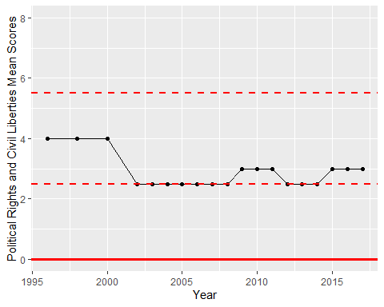

Freedom House Score Trend